8th March 2017

Southdene Medical Centre in Shotton Colliery is rated outstanding

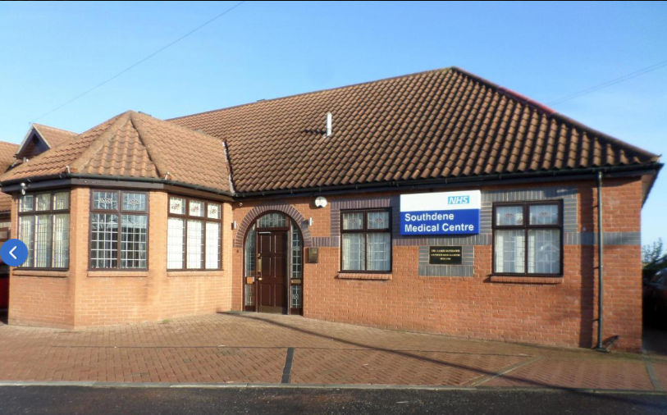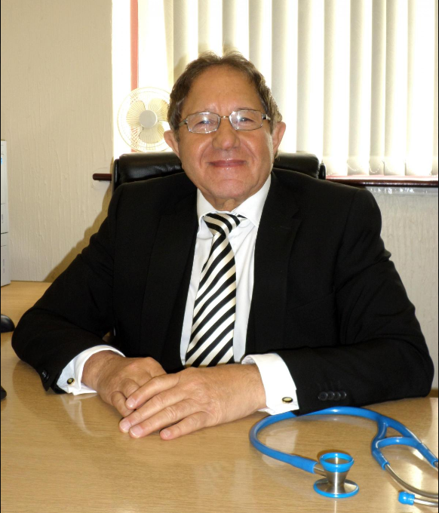
A MEDICAL practice is celebrating after getting a glowing report from a care watchdog.
The Care Quality Commission found the service provided by Southdene Medical Centre, Shotton Colliery to be outstanding following an inspection in November 2016.
Inspectors rated the practice as outstanding for safety, effectiveness and well-led and good for caring and responsiveness.
CQC deputy chief inspector of general practice in the North, Alison Holbourn said: “This is an impressive service that has a clear vision which had quality and safety as its top priority.
“Inspectors could see that there were strong arrangements in place to safeguard adults and children from abuse.
“For example, they regularly generated a report of children who missed appointments and of children who had injured themselves and attended the A&E department or out-of-hours service.
“These would be reviewed to identify trends and warnings signs which led to further action.”
She added: “The practice had been recognised locally over the years as having a good track record for the prescribing of medication.
“They were the second lowest prescribers of antibiotics in the locality out of 39 practices. The practice invested in its staff.
"There was continuing development of staff skills, staff received appropriate training for their roles and appraisals and supervisions were carried out for all staff. The nurse practitioner had been supported to train for this role.
“The practice is extremely well-led. There was constructive engagement with staff and a high level of staff satisfaction.
“The practice placed a strong emphasis on patient education. In addition to the usual education provided to patients during regular appointments they arranged an education programme with diabetic patients with a local renal consultant in May 2016.”
Senior partner Dr Samir Mansour said: “We were delighted to receive the news that Southdene Medical Centre has achieved an overall outstanding result.
“Our aim at Southdene is to provide the best possible care to our patients and it has boosted staff morale to receive the recognition for our efforts.”
“Our hope is that we will continue to provide an excellent service to the people of the “Easington area. We hope to continue to provide innovative education to our patients while fulfilling all of their healthcare needs.’’

